# CHAPTER - 1

# INTRODUCTION





.





##### 1.2 Objective of Project

* To detect the bullied text by using Deep learning alogorithm

**1.3 Scope & Limitations of project**

**Scope**

The scope of the proposed project is to develop an application,

* to classify the text into bullied and non-bullied.
* Limited to the selected dataset containing the features and attributes related to text data determines accuracy in detecting bullied text.

**Limitations of project**



**1.4. Existing System**



##### 1.5. Proposed System

##### 

##### 1.6. Modules

Modules are the units which are used for developing an application and implement a project.

The proposed project can be categorised as follows.

* Related literature has to be reviewed.
* The proposed algorithms and methods are described in detail.
* Requirement Gathering & Analysis
* System Design -Proposing Architecture, Model, Dataset Preparation & Pre-processing.
* Experimentation & Interpretation of Results
* Conclusion and Future Work

##### 1.7. Architecture

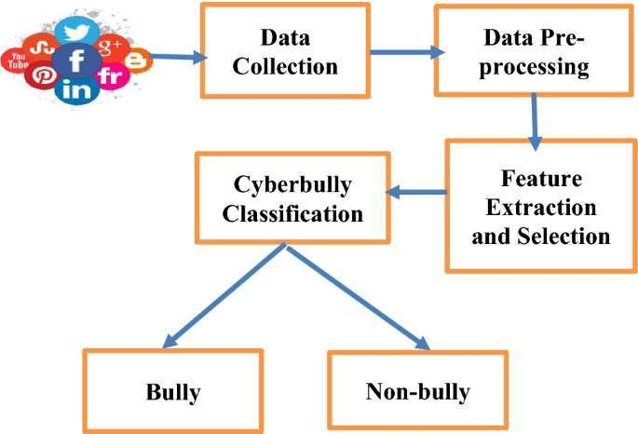System architecture comprises the major physical properties, style, structure, interactions, and purpose of a system." The purpose of system architecture activities is to define a comprehensive solution based on principles, concepts, and properties logically related to and consistent with each other. An architectural diagram is a diagram of a system that is used to abstract the overall outline of the software system and the relationships, constraints, and boundaries between components. It is an important tool as it provides an overall view of the physical deployment of the software system and its evolution roadmap.

Fig – 1.1: Architecture of proposed system

Dataset is pre-processed. Missing values, noisy data, and outliers if any has to be handled. Then the necessary features for building the model have to be extracted. Using TensorFlow, the dataset is trained and tested generating the confusion matrix to classify the credit card frauds. Further to predict whether the new data introduced (transactions) is fraudulent or not is determined using CNN.

**CHAPTER – 2**

**LITERATURE SURVEY**

Cyberbullying is a significant problem in today's society, and researchers have been working on developing detection systems to identify and prevent cyberbullying. One approach that has been explored is using machine learning algorithms such as Multilayer Perceptron (MLP) to detect cyberbullying. In this literature survey, we will discuss some recent works that have used MLP for cyberbullying detection.

"A Novel Cyberbullying Detection System Using MLP and SVM" by E. Koc and S. Demir. This paper proposes a hybrid MLP-SVM approach for detecting cyberbullying in social media. The authors used MLP to extract features from the textual data and then used SVM for classification. The proposed system achieved a high accuracy of 95% in detecting cyberbullying.

"Cyberbullying Detection Using MLP and Lexicon-Based Features" by S. Yan, X. Zhang, and Y. Liu. This study proposes an MLP-based cyberbullying detection system that uses both lexicon-based and syntactic features. The authors used a dataset of tweets to train and test their system and achieved an accuracy of 88.7%.

"Cyberbullying Detection in Arabic Social Media Using MLP and N-gram Features" by R. Alkhodair and A. Alarifi. This paper proposes an MLP-based system for detecting cyberbullying in Arabic social media. The authors used N-gram features to represent the textual data and achieved an accuracy of 89.12%.

"A Comparative Study of MLP and CNN for Cyberbullying Detection in Social Media" by S. K. Singh, A. Singh, and P. Gupta. This study compares the performance of MLP and Convolutional Neural Network (CNN) for cyberbullying detection in social media. The authors used a dataset of tweets and found that MLP achieved an accuracy of 85.7%, while CNN achieved an accuracy of 91.5%.

**CHAPTER - 3**

**PROPOSED METHODOLOGY**

Methodology refers to the overarching strategy and rationale of any project. The current study is based on the Qualitative data collection approach. Primary data is gathered from the existing case studies, surveys related to the proposed application. Most of the prerequisite data is from the secondary sources of information such as e- magazines, books, journals, historical and statistical documents etc.,

**3.1 Data Flow Diagram**

Fig – 3.1: Flowchart representing the end-to-end process.

* The data is taken as input which is in the .csv file format.
* The dataset is divided into training and testing data (generally the training data size consists of 70-80% and rest is taken as testing data)
* The model is trained by the given training data. By undergoing multiple epochs, the model tries to decrease the loss function for exact prediction and detection.
* By the multiple layered architecture of MLP, it is easy to formulate and extract the features to compare with the data given and comes out with the total number of actual bullied text , total number of bullied text detected, total number of non-bullied text.
* At last, the accuracy of the model to detect the bullied text is obtained.

**3.2 Dataset Description**

A dataset is an ordered collection of data. As we know, a collection of information obtained through observations, measurements, study, or analysis is referred to as data. It could include information such as facts, numbers, figures, names, or even basic descriptions of objects.

For any model to understand how to perform various actions, training datasets must first be fed into the machine learning algorithm, followed by validation datasets (or testing datasets) to ensure that the model is interpreting this data accurately.

Text datasets are highly imbalanced,. Handling imbalanced data is a crucial challenge in detection. Techniques like oversampling, under sampling, and cost-sensitive learning have been employed to address this issue.

The proposed project is carried over on the existing dataset.Cyberbullying data detection datasets typically include a wide range of features that can help identify fraudulent transactions, while the specific features may vary depending on the dataset.

* The dataset consists of multiple features like types of data like gender based , religious based
* Each attribute has its own importance. The dataset used is relatively small as it contains only some sort of huge text data

**3.3 Data Pre-processing Techniques**

Pre-processing data to ensure that it is in a format that the network can accept is a common first step in deep learning workflows.

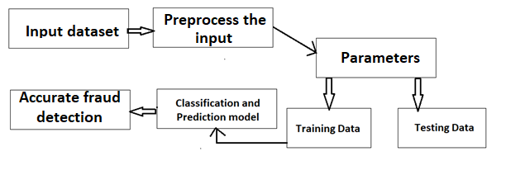

Fig – 3.2: Data pre-processing flow

Before preparing the data to be fed to the network the input dataset must be pre-processed.

* Obtaining some sample data.
* Cleaning the sample data.
* Splitting the data into training, validation, and test sets.

**3.4 Methods & Algorithms**

Method is a practical implementation of an approach. It also provides a detailed plan that helps to keep researchers on track, making the process smooth, effective, and manageable. A problem statement can be resolved or portrayed using various ways and can be solved using different methods. An algorithm is a sequence of logical steps to solve a problem.

**3.5 Building a Model**

**MultiLayer Perceptron**

A multilayer perceptron (MLP) is a type of artificial neural network commonly used for supervised learning tasks such as classification. MLPs are composed of multiple layers of interconnected neurons, where each neuron receives input from multiple neurons in the previous layer and produces an output that is passed to multiple neurons in the next layer.

Multi-layer perception is also known as MLP. It is fully connected dense layers, which transform any input dimension to the desired dimension. A multi-layer perception is a neural network that has multiple layers. To create a neural network we combine neurons together so that the outputs of some neurons are inputs of other neurons.

Multi-layer perception is also known as MLP. It is fully connected dense layers, which transform any input dimension to the desired dimension. A multi-layer perception is a neural network that has multiple layers. To create a neural network we combine neurons together so that the outputs of some neurons are inputs of other neurons.

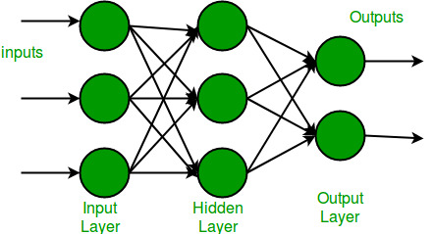

In the multi-layer perceptron diagram above, we can see that there are three inputs and thus three input nodes and the hidden layer has three nodes. The output layer gives two outputs, therefore there are two output nodes. The nodes in the input layer take input and forward it for further process, in the diagram above the nodes in the input layer forwards their output to each of the three nodes in the hidden layer, and in the same way, the hidden layer processes the information and passes it to the output layer.

**3.6 Evaluation**

.

The model on the testing set and prints the loss and accuracy scores.

The model finally evaluates the following:

* Basic investigation on the input dataset.
* Total number of lines of text .
* Number of bullied and non-bullied text.
* The accuracy of model to predict or detect bullied text after training.

**CHAPTER - 4**

**FINAL RESULTS**

pipe.predict(["@abc Hey man! Great match today. Your smashes were spot on. Let's continue playing together. \

#badminton #brotherhood #men #doubles"])

array(['not_cyberbullying'], dtype=object)

pipe.predict(["Going to Africa. Hope I don't get AIDS. Just kidding. I'm white!"])

array(['ethnicity'], dtype=object)

pipe.predict(["Muslims should be punished. We are not doing enough to rid us of those filthy animals."])

array(['religion'], dtype=object)

pipe.predict(["@abc Man you don't have any facial hair. You look like a fucking 9 year old school boy! #clown #idiot"])

array(['age'], dtype=object)

pipe.predict(["@abc shut up gay boy"])

array(['gender'], dtype=object)

<Axes: xlabel='cyberbullying_type', ylabel='count'>

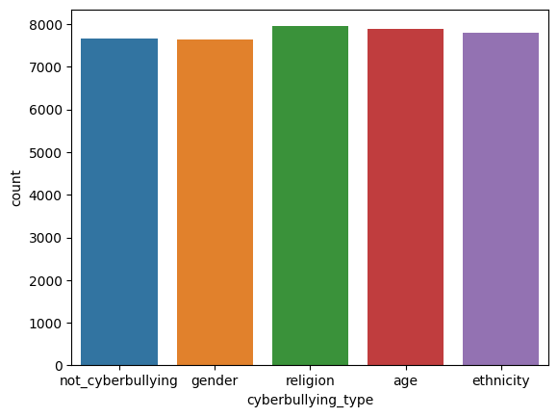

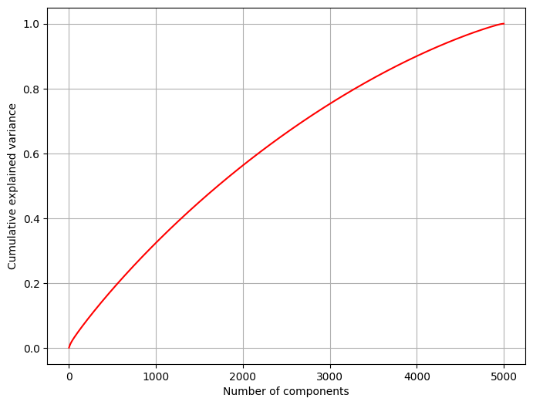

Text(0, 0.5, 'Cumulative explained variance')

precision recall f1-score support

age 0.96 0.97 0.96 766

ethnicity 0.98 0.98 0.98 801

gender 0.92 0.84 0.88 788

not_cyberbullying 0.80 0.85 0.82 783

religion 0.94 0.96 0.95 756

accuracy 0.92 3894

macro avg 0.92 0.92 0.92 3894

weighted avg 0.92 0.92 0.92 3894

**CHAPTER - 5**

**CONCLUSION**

**5.1 Project Conclusion**

The use of deep learning in the detection and prevention of cyberbullying is a promising area of research and development. Through the use of natural language processing and other advanced techniques, deep learning models can identify instances of cyberbullying with greater accuracy and efficiency than traditional approaches.

While deep learning models have shown great potential in detecting and addressing cyberbullying, it is important to remember that they are only as effective as the data they are trained on. Therefore, it is crucial to ensure that the data used to train these models is diverse and representative of different populations to prevent biases and ensure fairness. Additionally, human oversight and intervention are necessary to correct any false positives or negatives and ensure that any interventions are appropriately targeted.

In the future, we can expect continued growth and innovation in the use of deep learning and related technologies to prevent and address cyberbullying. This includes improved detection methods, personalized interventions, and considerations for ethics and privacy. Ultimately, by continuing to develop and refine these technologies, we can help make the internet a safer and more inclusive space for everyone.

**5.2 Future Scope**

Improved detection: As deep learning algorithms continue to evolve and become more sophisticated, they will likely become better at detecting cyberbullying with greater accuracy and efficiency.

Multimodal analysis: Currently, most cyberbullying detection models focus on analyzing text data, but future models could include analysis of other modalities such as images, videos, and audio recordings.

Personalization: By incorporating user-specific data and context, deep learning models could be personalized to identify individual patterns of cyberbullying and provide targeted interventions.

Prevention: While current models are focused on detecting cyberbullying after it has occurred, future models could potentially be used to prevent cyberbullying by providing real-time feedback to users as they compose messages.

Ethical considerations: As the use of deep learning models becomes more widespread in cyberbullying prevention, it will be important to address ethical considerations, such as ensuring that the models are transparent and fair, and that user privacy is protected.

**REFERENCES**

**Websites:**

1. Cyberbullying Research Center: https://cyberbullying.org/
2. StopBullying.gov: https://www.stopbullying.gov/cyberbullying/index.html
3. National Bullying Prevention Center: https://www.pacer.org/bullying/

**Books:**

* "Bullying Beyond the Schoolyard: Preventing and Responding to Cyberbullying" by Sameer Hinduja and Justin W. Patchin
* "Words Wound: Delete Cyberbullying and Make Kindness Go Viral" by Justin Patchin and Sameer Hinduja
* "Cyberbullying: Bullying in the Digital Age" by Robin M. Kowalski, Susan P. Limber, and Patricia W. Agatston

**Academic Articles:**

* "A Deep Learning Approach to Identifying Cyberbullying on Twitter" by Zhu et al. (2019)
* "Detecting Cyberbullying: Problems and Solutions" by Dinakar et al. (2011)
* "Detecting and Analyzing Online Hate Speech: A Multifaceted Study" by Schmidt and Wiegand (2017)